
Guidance Document on Calculating the Reduction in Payment for Nonconformance of Air Voids Requirements as per 401.03.07.H. “Hot Mix Asphalt (HMA) Courses, Air Void Requirements” of the Standard Specification for Road and Bridge Construction 2019 in conjunction with the FY 2019 Special Provisions for State Aid Projects
For any project that uses Hot Mix Asphalt, you will need to calculate a reduction in payment for nonconformance to air void requirements. This document will serve as a guide on how to calculate the reduction in payment for noncompliance with air voids requirements per section 401.03.07.H. “Hot Mix Asphalt (HMA) Courses, Air Void Requirements” in conjunction with the FY 2019 Special Provisions for State Aid Projects.
You will be given data for the air voids percent of the tested cores for the asphalt installed on your project from the DS-8S form “HMA Testing Summary Report – State Aid” (Example of the DS-8S form on page 16.) We will take this data and analyze it statistically. The first four pages of this document will summarize the steps of this process. The remaining pages of this document, with the exception of references, will examine how to perform each step in the process in-depth with an example.

The first step is to calculate the sample mean (X̅) and standard deviation (S) from the air voids percentage (X) from the number of cores (N) data set. X_{N} in this calculation is the air voids percentage of the Nth core. The calculation for doing such is found in 401.03.07.H.1.
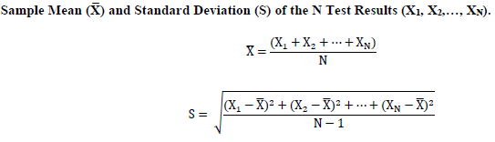

The second step is to calculate the quality index (Q) of the air voids data. Per 401.03.07.H, two percent to eight percent is the acceptable range of air voids. Q_{L} and Q_{U} will represent the lower and upper bounds for the acceptable range within the distribution of your air voids data. The Quality Index is a measure of how many standard deviations away from the sample mean the acceptable range of air voids is. [If you’re familiar with statistics, you’ll notice the similarities with calculating a Z score.]
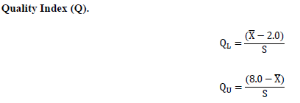

The third step is to calculate the Percent Defective (PD) of the air voids data.

PD = PD_{L} + PD_{U}

PD_{L} and PD_{U} correspond with Q_{L} and Q_{U} respectively. PD_{L} and PD_{U} are found by looking up the values in the “NJDOT ST – Statistical Tables” section starting on page 574 of the Standard Specification for Road and Bridge Construction 2019. These tables are an estimation of percent defective for sample sizes of data. For example, “Table ST-5 Estimation of Lot Percent Defective for Sample Size 5” is made for a sample size of five pavement cores. On the leftmost column of the table, you will match up the ones and tenths place of your Q value. Then using the “Q¹” row, you will pick out the hundredths place of your Q value. The PD corresponding to your Q value is the intersection of the column and row of your Q value. Lastly, you add up the PD_{L} and PD_{U} you’ve looked up on the Statistical Tables to get your total PD.
Retest. If the initial series of 5 cores produces a percent defective value of PD greater than or equal to 30, the Contractor may elect to take an additional set of 5 cores at random locations chosen by the ME (the Department’s Manager of the Bureau of Materials, or the Department’s Regional Materials Engineer and their designated representatives). Take the additional cores within 15 days of receipt of the initial core results. If the additional cores are not taken within the 15 days, you will use the initial core results to determine the reduction in payment for nonconformance to air voids requirements. If the additional cores are taken, then you will recalculate the reduction in payment using the combined results from the 10 cores.

The fourth step is to check whether there is an outlier in your data set. Per 401.03.07.H.5, you will not screen for outliers if the PD < 10. If PD ≥ 10, the following procedure will determine if the outlier is statistically significant.

- Arrange the core results in in ascending order, in which X₁ represents the smallest value and X_{N} represents the largest value.
- If X_{N} is suspected of being an outlier, calculate:
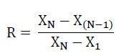
- If X₁ is suspected of being an outlier, calculate:
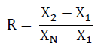
- For N = 5: if R > 0.642, the value is judged to be statistically significant and the core is excluded. For N = 10: if R > 0.412, the value is judged to be statistically significant and the core is excluded.

If an outlier is detected for a test of 5 cores and no retest is warranted, the Contractor may replace that core by taking an additional core at the same offset and within 5 feet of the original station. If an outlier is detected and a retest is justified, take a replacement core for the outlier at the same time as the 5 additional retest cores are taken. If the outlier replacement core is not taken within 15 days, you will use the initial core results to determine the reduction in payment.

If an outlier is detected for N = 10, the Contractor may replace that core by taking an additional core at the same offset and within 5 feet of the original station. If the outlier replacement core is not taken within 15 days, you will use the initial core results to determine the reduction in payment.

The fifth and final step is to lookup the reduction in payment for nonconformance to air void requirements for the HMA using the PD. You will need to use “Table 401.03.07- Reduction in Payment for Nonconformance to Air Void Requirements” provided in the FY 2019 Special Provisions for State Aid Projects and copied below.

Table 401.03.07-3
Reduction in Payment for Nonconformance to Air Void Requirements
Percent Defective (PD) Per Lot | Reduction Per Lot (%)
0 < PD ≤ 15 | 0
15 < PD ≤ 30 | 0.5
30 < PD ≤ 35 | 2
35 < PD ≤ 40 | 10
40 < PD ≤ 45 | 15
45 < PD ≤ 50 | 20
50 < PD ≤ 60 | 30
60 < PD ≤ 75 | 45
PD > 75 | Remove & Replace

Categorize your PD of air void percentage value in the left column accordingly and remember this row. Pick out the Reduction Per Lot in the second column which corresponds to the row of your PD value. The value in the second column is the reduction in percentage that will be reduced on the cost of the pay item for the hot mix asphalt that was tested in this coring sample.

What is the difference between this method and the method Local Aid has been using since 2011?
The method established in the Special Provisions for State Aid projects 2011 utilizes the sample mean of the cores tested. How much this sample mean varied from the acceptable range of 2.0% - 8.0% air voids was used as the basis to determine a reduction in payment percentage. Different tiers of nonconformity from the acceptable range determined the reduction in payment, which consisted of higher penalties for a higher degree of nonconformity. This is a measure of how badly the sample mean violates the acceptable range. This does not take into account the quantity of the HMA that is nonconforming or defective, but only the average.
The method from the Standard Specification for Road and Bridge Construction 2019 is based on statistical analysis to produce a percentage amount of the lot that is nonconforming with the acceptable range, which is called percent defective (PD). The reduction in payment percentage is based on different tiers of how high the percent defective amount is, or how much of the HMA lot falls outside the acceptable range of air voids requirements. In short, this method is a measure of how much HMA does not conform to the acceptable range of air voids percentage 2% - 8%. This is a measure of the quantity of unacceptable HMA on the lot being tested. This does not take into account tiers of how badly the defective HMA is, but only counts defective HMA as simply defective.
The 2011 method tests for how high the nonconformity of the sample mean deviates from the acceptable range, whereas the 2019 method tests for how much of the HMA is actually nonconforming to air voids requirements.
Air voids percentage is a measure of how well the HMA is compacted. The longevity of HMA is reliant on how well the HMA is compacted. More voids means the HMA is more permeable, which translates to more air and water seeping into the HMA. More water seeping into those voids means that the water will cause more cracks and fractures at a faster rate, when the water expands and contracts due to seasonal weather changes. As a general rule-of-thumb, pavement life is reduced by about 10% for each 1% increase in air voids (Linden et al., 1 [1]).

The rest of this document, except for references, is dedicated to step by step instructions on how to complete a statistical analysis of a five-cylinder test, calculating the percent defective, and establishing the correct reduction in pay per line item of HMA.

Example of Step 1
Determine the sample mean and standard deviation for a given set of data.
Coring Samples: | Core #1 | Core #2 | Core #3 | Core #4 | Core #5
% Air Voids | 7.9 | 5.9 | 7.8 | 7.9 | 10.1

(X̅) Sample Mean
(S) Standard Deviation
(X) Air Voids Percentage
(N) The number of cores = 5

X̅ = $\frac{7.9 + 5.9 + 7.8 + 7.9 + 10.1}{5}$ = 7.92
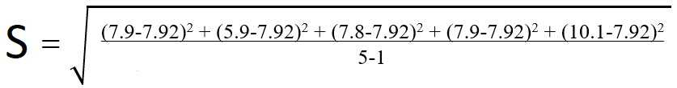
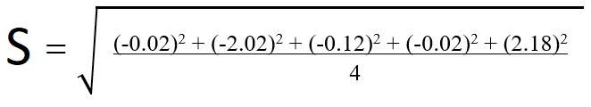
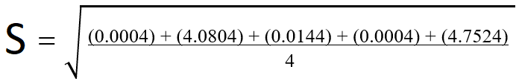
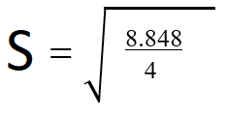
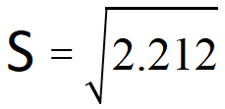
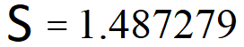
Conclusion: The sample mean is 7.92 and the standard deviation is 1.487279.
What this number means as real world results: When the data set is analyzed, the average amount of air voids in the hot mix asphalt lot is 7.92% with a standard deviation of 1.487279%. Sixty-eight percent of the hot mix asphalt lot tested has between 7.92% ± 1.487279% air voids. Ninety-five percent of the hot mix asphalt lot tested has between 7.92% ± 2.974558% air voids. Ninety-nine and seven tenths percent of the hot mix asphalt lot tested has between 7.92% ± 4.461837% air voids.
The central limit theorem of statistics teaches that taking a random sample of a data set of a random and independent variable will tend toward a normal distribution or bell curve, even if the original variable is itself not normally distributed (Watkins, 193-196 [2]). This allows us to use a normal distribution to analyze our random sample data set [asphalt coring data] for a random and independent variable [air voids percentage] and draw conclusions about the HMA the coring is from. A normal curve is more commonly referred to as a bell curve, and one is pictured below.
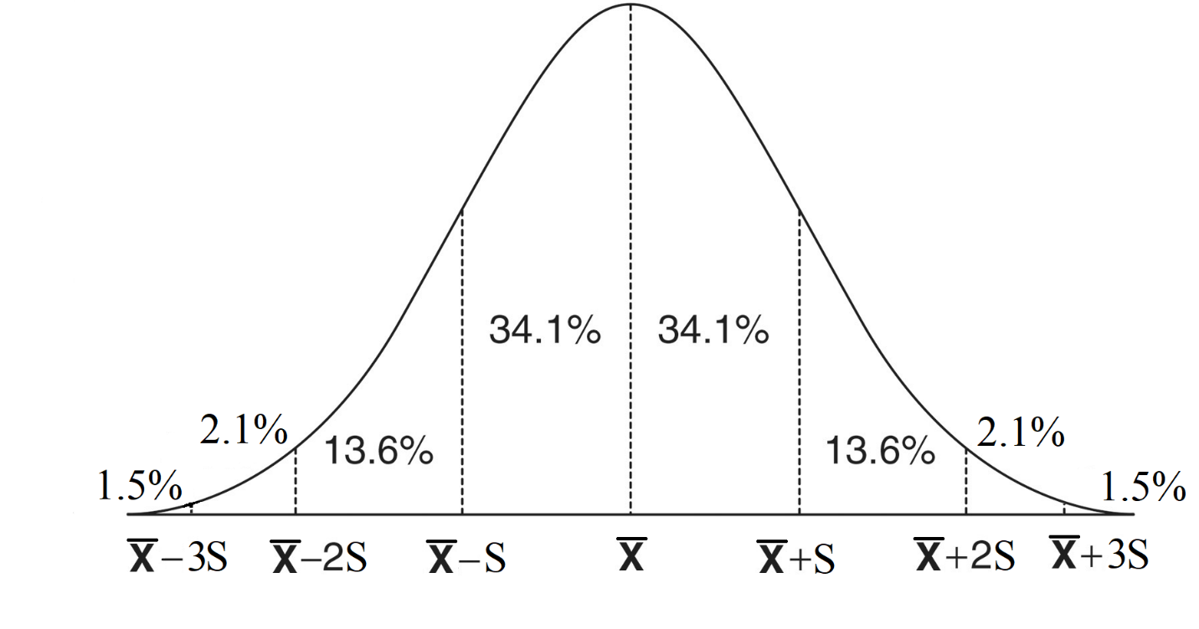
The empirical rule of statistics states that nearly all the data of a normal distribution falls within three standard deviations above and below the mean in a normal distribution. More specifically: 68% of the data set is one standard deviation above and below the mean; 95% of the data set is two standard deviations above and below the mean; and 99.7% of the data set is three standard deviations above and below the mean (Spiegel and Stephens, 98-99 [3]). This is broken up incrementally on the graph above. On Graph Example 1 below, we see what the normal distribution looks like for our data set:
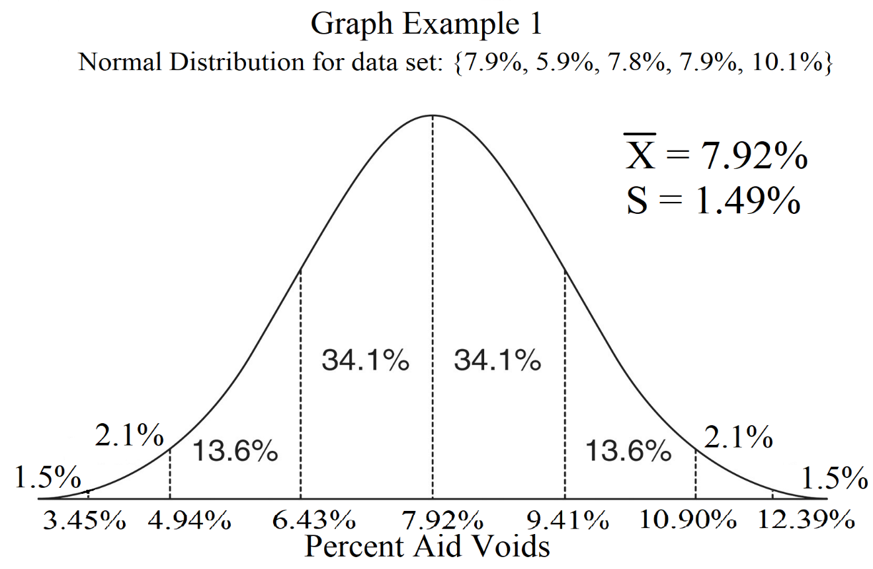
Per 401.03.07.H, 2.0% - 8.0% is the acceptable range of air voids. We can see that 8.0% is slightly greater than our sample mean of 7.92%, and we see that 2% is virtually the left corner of the bell curve. Using the empirical rule of statistics, we can estimate that a little more than 50% of our data set is within the acceptable range. A little less than 50% of our data is outside of the acceptable range or the percent defective of our data is a little less than 50% of the data set. We will calculate exactly how much of our data is outside of the acceptable range in step 3. However, this gives us an intuition on what our percent defective should be in step 3.
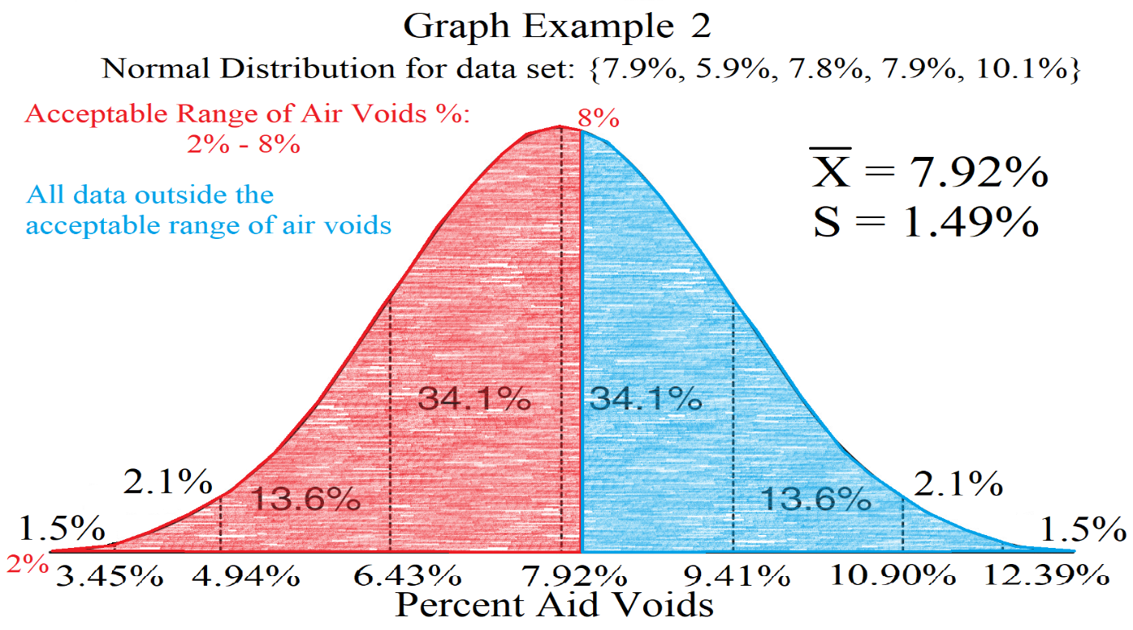

Example of Step 2
Determine Q_{L} and Q_{U} from a given sample mean and standard deviation.
X̅ Sample Mean = 7.92
S Standard Deviation = 1.487279
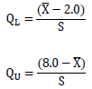
Q_{L} $=\frac{(7.92-2.0)}{1.487279}$ = 3.98
Q_{U} $=\frac{(8.0-7.92)}{1.487279}$ = 0.05

Example of Step 3: How to Read and Interpret the Statistical Tables
Determine the PD_{L} & PD_{U} for a given a Q_{L} and Q_{U}.
Q_{L} = 3.98
Q_{U} = 0.05
As an example of how to use the Statistical Tables, let’s find the PD_{L} & PD_{U} of a Q_{L} = 3.98 and a Q_{U} = 0.05 in a data set with 5 cores. In the “NJDOT ST – Statistical Tables” section, we find the appropriate table for our sample size of 5 is “Table ST-5 Estimation of Lot Percent Defective for Sample Size 5”. We’ll start by finding PD_{U} of Q_{U} = 0.05 first.
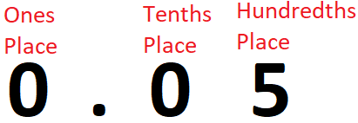
The ones place value is 0. The tenths place value is 0. The hundredths place value is 5. Now we will look at the column under Q¹ and find the amount equal to our ones place and tenths place of our Q_{U}.
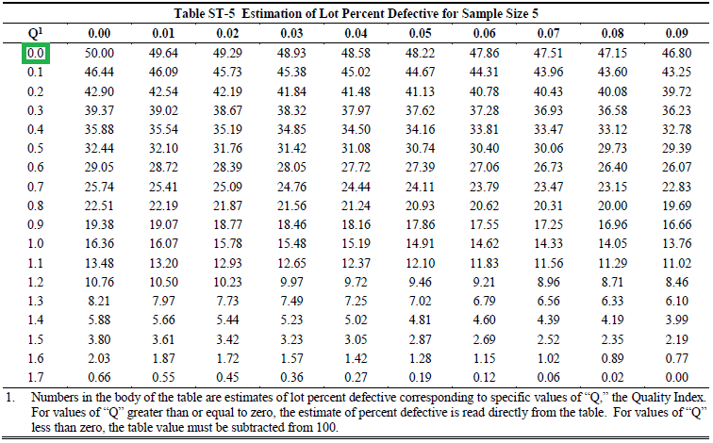
Now we will look at the top row of Q¹ and find the amount equal to our hundredths place of our Q_{U}.

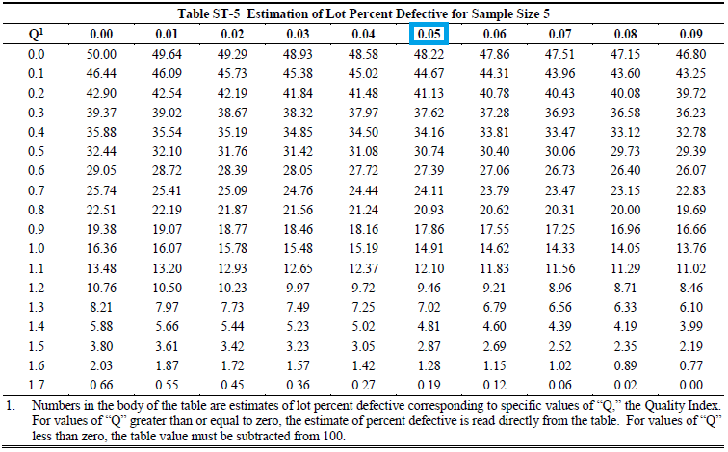

Now we must find the intersection of the row of the ones and tenths place of our Q_{U} with the column of the hundredths place of our Q_{U}. The value at the intersection will be the PD_{U} value. This process looks like this:
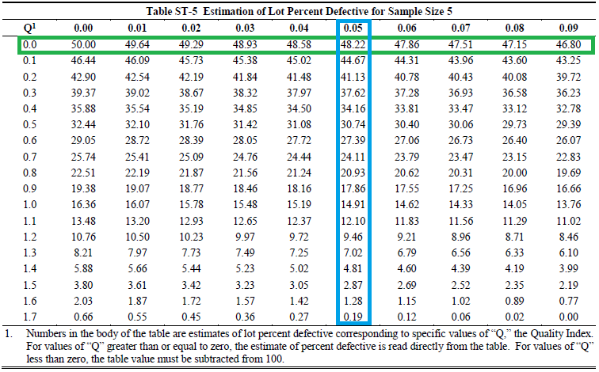
PD_{U} = 48.22

Next we move on to find Q_{L}
Once again, we move find the ones place and the tens place of our Q_{L} value on “Table ST-5 Estimation of Lot Percent Defective for Sample Size 5”. Now we notice that the maximum Q value listed on Table ST-5 gives is 1.79, which corresponds to a PD value of 0.00. Any Q value greater than 1.79 on a sample of 5 cores will yield a PD value of 0.00. As the trend in the table shows: as the Q values increase, the PD value decreases.
PD_{L} = 0.00
Now we can solve for the total PD.

PD = PD_{L} + PD_{U}

PD = 0.0 + 48.22 = 48.22

What this number means as real world results: Based on analyzing the coring data statistically, 48.22% of the HMA in the tested lot falls outside the acceptable range of 2.0% – 8.0% air voids. 48.22% percent of the HMA lot the coring comes from is defective. (The contractor can elect for a retest with five additional pavement cores, since the PD is above 30% as per 401.03.07.H.6.)
Based on the distribution and statistics we calculated in Step 1, this PD makes sense. Using the central limit theorem and empirical rule, we concluded that a little less than 50% of the data set would fall outside the acceptable range and be defective. Graph Example 2 is repeated here to illustrate this point.
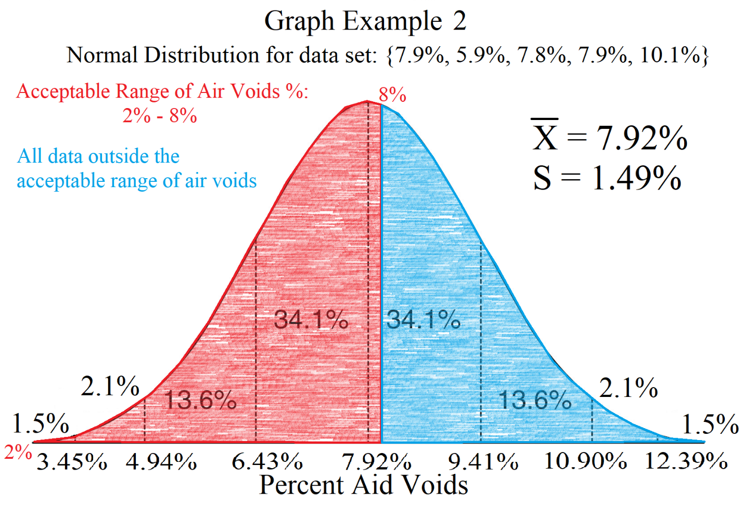
As another exercise, let’s try repeating this step for a negative Q value. What is the PD for Q = -0.26?
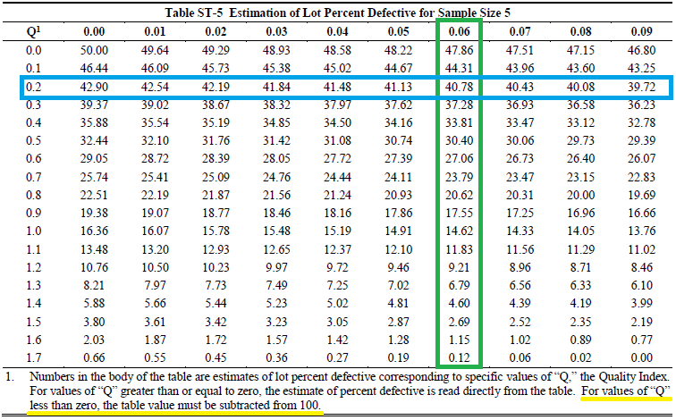
There is a note at the bottom of the table explaining how to use the table for negative Q values. To get the proper PD value, look up your Q value as if it’s a positive number. Then subtract that positive Q value from one hundred. The difference of that subtraction is the PD value for your original negative Q value.
Q = -0.26. The positive version of -0.26 is 0.26. We look up the value of Q = 0.26 and find that it is 40.78.
We subtract 40.78 from one hundred to get: 100 – 40.78 = 59.22. This is our PD value.

Example of Step 4
Calculate the Payment Reduction Percentage for a given set of data and line item price.
Percent Defective (PD) = 48.22
One lot of 9.5M64 Surface Course Asphalt line item total = $50,000.00
We must refer to table “Table 401.03.07-3 PPA for Mainline lots and Ramp Lots” provided in the FY 2019 Special Provisions for State Aid Projects.
Table 401.03.07-3
Reduction in Payment for Nonconformance to Air Void Requirements
Percent Defective (PD) Per Lot | Reduction Per Lot (%)
0 < PD ≤ 15 | 0
15 < PD ≤ 30 | 0.5
30 < PD ≤ 35 | 2
35 < PD ≤ 40 | 10
40 < PD ≤ 45 | 15
45 < PD ≤ 50 | 20
50 < PD ≤ 60 | 30
60 < PD ≤ 75 | 45
PD > 75 | Remove & Replace

Our PD value is 48.22, which puts our testing lot in the sixth row. In the second column, we can see the percentage reduction for the sixth row is 20. The reduction in the amount of the hot mix asphalt line item corresponding to the HMA lot that was tested in this coring sample is 20%. This means that the amount of money that is reimbursable by the grant administered by the New Jersey Department of Transportation for the 9.5M64 Surface Course Asphalt line item is $50,000.00 – ($50,000.00 x 0.20) = $40,000.00. The grant award amount for the HMA line item has decreased by $10,000.00

Comparison to 2011 Method of Reduction of Payment:
The table used for calculating the reduction of payment from the 2011 edition of the Special Provisions for State Aid Projects is supplied below.
Table 401.03.03-3 Reduction for Nonconformance to Air Voids Requirements
Lot Average Air Void Value  (Five Samples) | Reduction Per Lot  (Percent of Lot)
0.0 to 1.9 | 10
2.0 to 8.0 | 0
8.1 to 9.0 | 5
9.1 to 10.0 | 15
10.1 to 12.0 | 30
Over 12.0 | Remove & Replace

Our parameters are percent defective (PD) = 48.22 and sample mean (X̅) = 7.92% air voids.
With the 2019 edition of the Special Provisions for State Aid Projects method, we found that 48.22% of the HMA does not meet the acceptable range of air void percentage, which resulted in a penalty of 20%.
The method used by the 2011 edition of the Special Provisions for State Aid Projects only looks at the sample mean of the coring samples. In this case, the sample mean falls within the acceptable range of 2.0% - 8.0%, and no payment reduction is needed.
This is an example of how much the method used by the 2011 edition and the 2019 edition of the Special Provisions for State Aid Projects differs. With the 2011 edition method, no payment reduction would be rendered because the sample mean falls within the acceptable range, despite 48.22% of the pavement lot exceeding the air voids requirement. Using the 2019 method, a penalty of 20% in the reduction of the pay item is rendered by 48.22% of the pavement being defective.

Example of Step 5
Determine if there are any outliers in a given data set.

Coring Samples: | Core #1 | Core #2 | Core #3 | Core #4 | Core #5
% Air Voids | 7.9 | 5.9 | 7.8 | 7.9 | 10.1

PD = 48.22
Per 401.03.07.H.5, you will not screen for outliers when the PD < 10. Our PD is greater than 10, so we must proceed. Let’s begin the procedure as described per 401.03.07.H.5:
- Arrange the core results in in ascending order, in which X₁ represents the smallest value and X_{N} represents the largest value.
Coring Samples: | X₁ | X₂ | X₃ | X₄ | X₅
% Air Voids | 5.9 | 7.8 | 7.8 | 7.9 | 10.1

- If X_{N} is suspected of being an outlier, calculate:
In our case, X_{N} = X₅ = 10.1; X_{(N-1)} = X₄ = 7.9; and X₁ = 5.9. Our R calculation is:
R = $\frac{10.1-7.9}{10.1-5.9}$ = $\frac{2.2}{4.2}$ = 0.5238
- If X₁ is suspected of being an outlier, calculate:
In our case, X_{N} = X₅ = 10.1; X₂ = 7.8; and X₁ = 5.9. Our R calculation is:
R = $\frac{7.8-5.9}{10.1-5.9}$ = $\frac{1.9}{4.2}$ = 0.4524

- For N = 5 if R > 0.642, the value is judged to be statistically significant and the core is excluded. For N = 10 if R > 0.412, the value is judged to be statistically significant and the core is excluded.
We investigated the largest and smallest values in the data set. In both instances, our R values were less than 0.642. Therefore our data set contains no outliers.

Form DS-8S Example
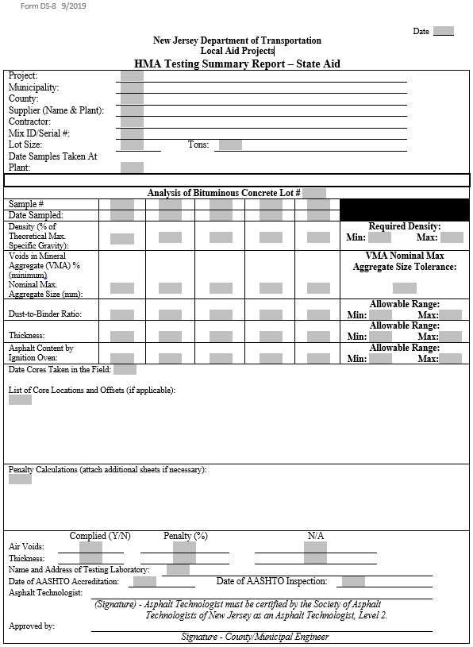

Certificate of Compliance Form Example

Project:

Municipality:

County:

Contractor:

Supplier (Name & Plant):

Material Description:

Material Quantity:

Date of Shipment:

Shipment Identifier:
(such as label marking
or seal number)

These materials conform to the project contract material requirements, and the representative samples have been tested and found to be in compliance with the project contract. |  |  |  |  |  |  |  |  | (checkbox)
If this submission is for an assembly of materials, I confirm that the assembly conforms to the project contract. |  |  |  |  |  |  |  |  | (checkbox)
I have the legal authority to bind the supplier of these materials to this project’s contract. |  |  |  |  |  |  |  |  | (checkbox)
Clearly Print/Type Name:
Signature:
Approved by:
Clearly Print Name – County/Municipal Engineer |  |  |  |  |  |  | Signature – County/Municipal Engineer

(After approval submit to the Local Aid Projects District Office)

References

- Linden, R.N.; Mahoney, J.P. and Jackson, N.C. (1989). The Effect of Compaction on Asphalt
Concrete Performance. 1989 Annual Meeting of the Transportation Research Board, Washington, D.C.
- Watkins, Joseph C. “The Central Limit Theorem.” An Introduction To The Science Of Statistics:
From Theory To Implementation, Preliminary Edition., https://www.freetechbooks.com, 2016, pp. 193–196.
- Spiegel, Murray R., and Larry J. Stephens. “The Standard Deviation and Other Measures of
Dispersion.” Theory and Problems of Statistics, Fourth Edition., McGraw-Hill, 2003, pp. 98–99.

