NJDOT High Friction Surface Treatment (HFST) Guidelines

Overview
High friction surface treatment (HFST) is a safety enhancement that improves and/or restores pavement friction to reduce crashes. Many lane-departure and intersection crashes occur when vehicle speed and roadway geometry create a “friction demand” higher than can be achieved from the pavement surface. HFST (Figure 1) is a thin layer of high quality aggregate bonded to the pavement surface with a uniformly controlled application of polymeric liquid binder adhesive to increase the friction capacity of the pavement.

Figure 1 – High Friction Surface Treatment (HFST)
HFST is NOT a pavement treatment to utilize as a “Band-Aid” in an attempt to extend the life of roadway with any significant amount of surface distress. HFST is only suitable for use on pavements that a pavement engineer would consider as “good” to “excellent” condition. Never apply HFST on pavement with questionable or poor condition to try to “Band-Aid” or extend the life of the pavement. Using HFST to try to preserve a questionable or poor condition pavement may have the opposite result. In fact, in some cases the HFST has actually accelerated pavement deterioration on roadways in NJ that were not in “good” condition. HFST will only last as long as the underlying “good” pavement allows when installed using the approved materials and good construction practices.

Safety Performance & Research
The Federal Highway Administration (FHWA) reports that:
High friction surface treatments (HFST) are pavement treatments that dramatically and immediately reduce crashes, injuries, and fatalities associated with friction demand issues, such as:
- A reduction in pavement friction during wet conditions, and/or
- A high friction demand due to vehicle speed and/or roadway geometrics.
Pennsylvania, Kentucky and South Carolina DOTs report a before/after total crash reduction of 100 percent, 90 percent, and 57 percent, respectively, for their signature HFST trial projects.
Because FHWA is encouraging the use of HFST under Every Day Counts, and other states have experienced dramatic improvements in crash reductions, NJDOT began installing HFST on select pilot projects in 2016. NJDOT is currently collecting data on these HFST pilot projects. The collected data will be analyzed to evaluate HFST and optimize its performance and use in New Jersey. NJDOT is continuing the pilot program by installing additional HFST sites in select locations where appropriate. Other alternative high friction treatments are also being researched and some pilot test sections being installed and monitored for performance. HFST and alternative high friction treatments data collection and analysis will continue, performance will be monitored, and findings will be utilized to improve the NJDOT HFST program.
Additional information is available at the following FHWA websites:
https://safety.fhwa.dot.gov/roadway_dept/pavement_friction/high_friction/
https://www.fhwa.dot.gov/innovation/everydaycounts/edc-2/hfst.cfm

Screening Criteria
Determination of locations where application of HFST are appropriate should meet specific safety and geometric criteria. These criteria are as follows:

Appropriate Pavement Conditions for HFST

General
HFST has a lifespan of 5 to 7 years under heavy traffic, and 10 to 15 years for low traffic. Most of the roadways in New Jersey are heavy traffic to very heavy traffic, especially the NJDOT roadway network. Therefore, to ensure the return on the HFST investment, locations selected for HFST application should be done so prudently and the underlying pavement should have a remaining service life (RSL) similar or greater than the expected life of the HFST. HFST is expensive and therefore should be placed only in locations that meet NJDOT criteria, which have good pavement condition and will yield the most return on the investment. NJDOT has some varying experience concerning how to evaluate and determine if a pavement is in “good” enough condition for applying HFST. Based on that experience, NJDOT determined that this guidance document was necessary to assist engineers and maintenance personnel in selecting appropriate pavement sections for HFST. This document is intended also to provide a systematic way to evaluate and repair the pavement when the surface condition is questionable and may not be suitable for HFST placement. HFST is only appropriate to install on structurally adequate and functionally sufficient pavements, which are considered in “good” condition. Pavements planned for preventive maintenance, resurfacing, rehabilitation or reconstruction should not be programmed for HFST without coordination with the planned work to make the most efficient use of funding. Pavements determined to be structurally adequate, smooth, exhibiting “good” surface condition (or functional sufficiency) with little to no surface distress, and are 2 years in age or less since the last surface placement may be considered for HFST. HFST may be installed over asphalt surfaced (Figure 2) and/or concrete surfaced (Figure 3) pavements.
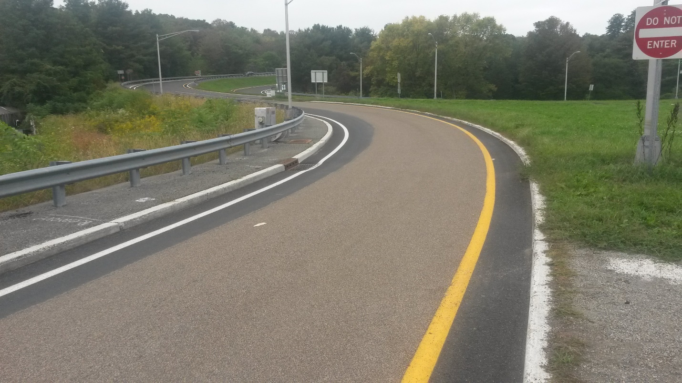
Figure 2 – HFST on Asphalt Surfaced Pavement
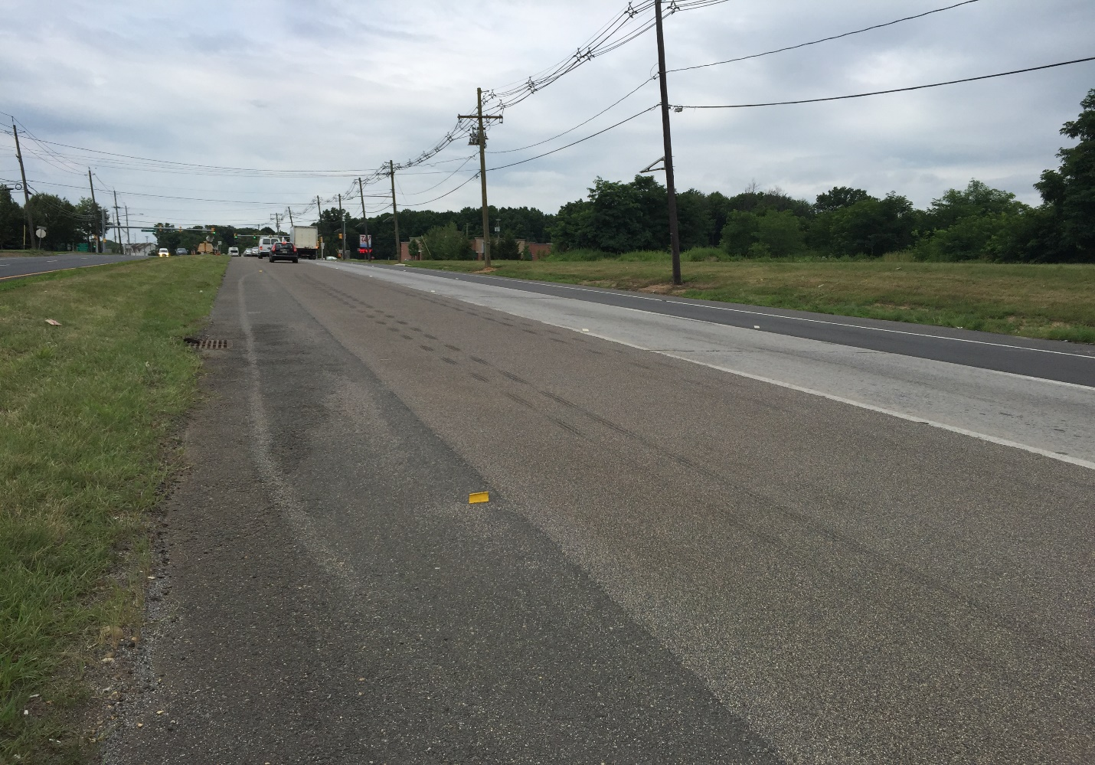
Figure 3 – HFST on Concrete Surfaced Pavement
The general guidance for determining if the pavement condition is acceptable for installing HFST is as follows:
- Newer asphalt or concrete pavement
  - Asphalt pavement less than 2 years old
  - Concrete pavement less than 10 years old
- Pavement surface condition rating of “good” or better
- Pavement structurally adequate
- Quality of existing pavement material is known and considered sufficient
- Polished surface with low skid resistance measured as per ASTM E 274
- No cracking or very minimal low severity cracking
- Smooth pavement
- No rutting or shoving
- Good pavement surface drainage
- Clean and dry surface

Pavement Condition Related HFST Performance Issues
New Jersey has experienced some HFST failures since the pilot program began in 2016 due to placement of HFST over pavements that were in questionable condition. Failures on NJ projects were determined to be due to two major factors:
- Asphalt pavement tensile strength. The tensile strength of the asphalt pavement was not adequate where the HFST was installed. Tensile strength of asphalt core samples is evaluated using ASTM test method C 1583 and evaluated by an experienced pavement engineer. HMA with low or inconsistent tensile strength is an indicator of a weak and unsuitable substrate for HFST.
- Coefficient of Thermal Expansion difference between HFST and asphalt substrate. The increased stress in locations of high friction demand due to vehicle tire forces and environmental stress induced by thermal cycling. The difference in the coefficient of thermal expansion (COTE) between the HFST polymeric resin binder, COTE between 14 and 30 x 10⁻⁶/°F, and the asphalt pavement surface, COTE between 7 and 9 x 10⁻⁶/°F, has been shown to induce stress with thermal cycling (Wilson and Mukhopadhyay, 2016) between the HFST binder and the weak asphalt. This added stress to the pavement can accelerate asphalt deterioration leading to asphalt failure and thus HFST failure as shown in Figure 4 and Figure 5.
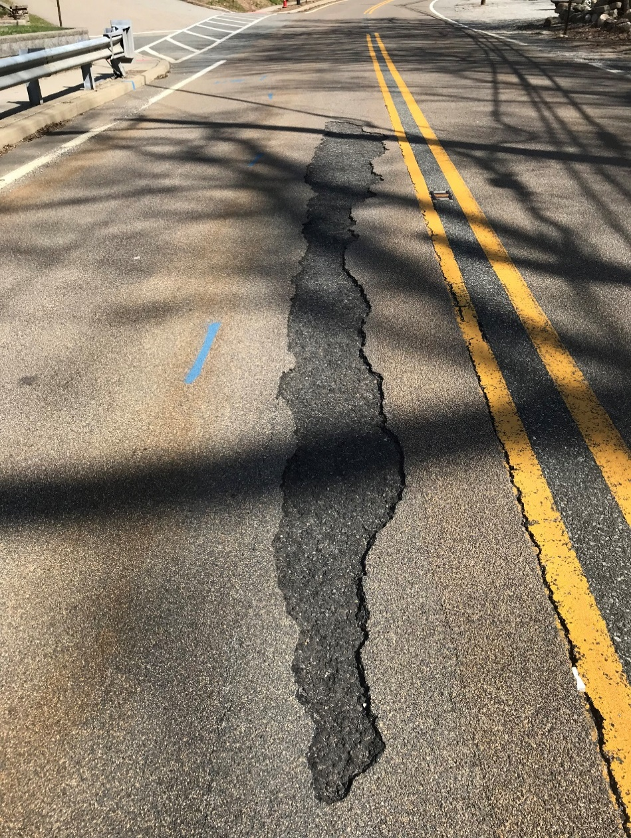
Figure 4 – Failure of HFST and Asphalt Substrate

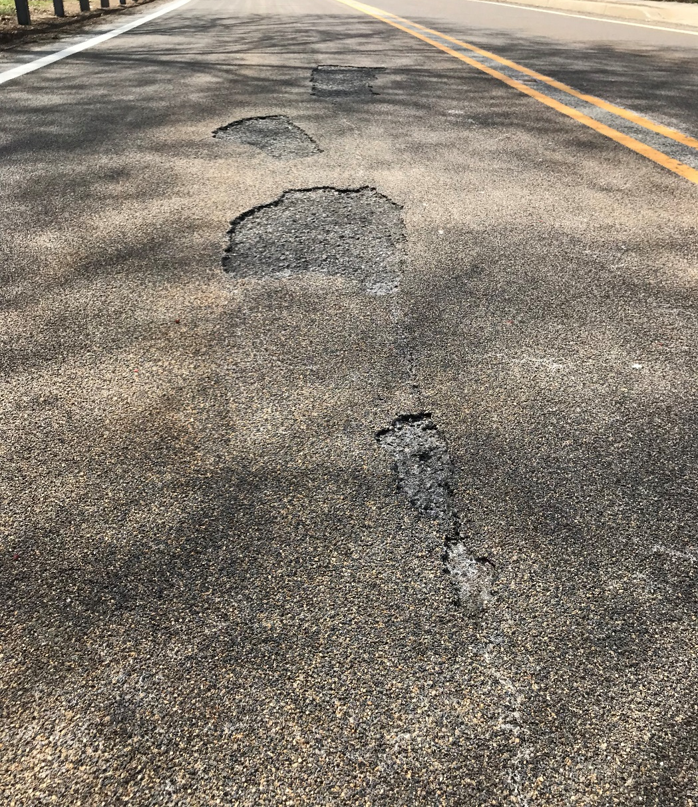
Figure 5 – Failure of HFST and Asphalt Substrate

Other agencies have also experienced similar failures in addition to other performance issues. Because of these expensive failures, it is critical to ensure the pavement conditions are acceptable for installation of HFST immediately prior to placement.
In addition to not placing HFST on structurally deficient or functionally insufficient pavements, HFST should also NOT be installed on open graded friction course, chip seal, slurry seal, micro surfacing, ultra-thin friction course, and other thin surface treatments that are less than 1” thick. FHWA subject matter experts and other agencies have experienced failures of HFST on these types of surfaces and do not recommend HFST placement on these surface types.

Specific Pavement Conditions & Repairs
For roadways under NJDOT jurisdiction, NJDOT Pavement & Drainage Management & Technology (NJDOT PDM&T) unit should be consulted prior to installation of HFST. NJDOT PDM&T will determine if the condition of the pavement is acceptable for HFST. NJDOT PDM&T unit collects the entire network of roadways within NJDOT jurisdiction each year measuring surface distress, rutting ride quality, and high-resolution digital images. This data is very helpful for review when screening proposed HFST sections. If upon review, it is determined that the pavement is not in acceptable condition for HFST, then NJDOT PDM&T unit will provide a more detailed pavement evaluation. From the pavement evaluation, NJDOT PDM&T unit will provide pavement design recommendations to repair, resurface or reconstruct the pavement prior to applying the proposed HFST sections. Pavement planned for HFST should be visually inspected using the procedure in the Distress Identification Manual for the Long-Term Pavement Performance Program (FHWA Publication No. FHWA-RD-03-031, June 2003) and a detailed pavement condition assessment documented for analysis. An experienced pavement engineer will review the pavement condition assessment, PMS data, as-built and QA/QC data. Based on a review of the data, the pavement engineer should ensure the surface is structurally adequate and functionally sufficient (in “good” condition) or recommend pavement repairs. The summary of the steps involved in assessing a pavement to determine if it is a good candidate for HFST are as follows:
- Review pavement management system (PMS) data such as International Roughness Index (IRI), surface distress, cracking, skid resistance, rutting and faulting.
- Review as-built, quality control (QC) and quality acceptance (QA) data from last project
- Perform a visual pavement condition assessment
- Perform a Pavement Evaluation
- Perform laboratory testing of pavement material(s)
- Provide Pavement Design Recommendations as required prior to applying HFST
If the pavement condition is “good” then HFST may be applied with no additional pavement repairs or treatments. If it needs some repairs or treatments, then the Pavement Design Recommendations will provide the necessary actions prior to applying HFST. The following is a list of more specific distresses when performing a visual distress survey and considering if a pavement is a “good” candidate based on surface condition, why these conditions are important and what remediation is required to ensure that the pavement condition is acceptable prior to applying HFST:

Asphalt Surfaced Pavements
- Cracking. No structural cracking should be present such as fatigue (alligator), block, longitudinal wheel path, and edge cracking. Pavements exhibiting few low severity non-structural cracks less than ¼” wide may be acceptable for HFST such as localized transverse cracks and longitudinal cracks/joints outside the wheel path of vehicles. Moderate and high severity cracks need to be treated prior to applying HFST. Non-structural cracks that are raveling and have other connected cracks are not acceptable for HFST and should be repaired or treated.
  - Cracks will reflect through HFST and may cause premature failure or reduced life of the treatment.
  - Cracks may indicate a potential structural deficiency, asphalt layer debonding and/or weak surface material.
  - Clean and fill localized transverse cracks and longitudinal cracks outside of the wheel paths, greater than ¼” and less than 1-1/2” width using an approved crack sealant or the approved blended HFST binder resin.
  - Transverse cracks greater than 1-1/2” width may require repair or may disqualify the location for HFST.
  - Longitudinal cracks inside the wheel path of vehicles, localized high severity cracks (Figure 6), or interconnected cracks, using an appropriate approved HMA surface course and good construction practices that meet NJDOT standards.
  - Mill and resurface pavements with a high amount of cracking or high amount of localized areas needing repairs to the full width and depth of the affected layer(s) with approved asphalt pavement materials.
  - A pavement evaluation may be required to determine the proper pavement design recommendation. Pavements that exhibit fatigue cracking, which is a structural distress, typically require reconstruction or structural enhancement. A pavement evaluation should be performed to determine the cause of fatigue cracking. An experienced pavement engineer should review the pavement evaluation and then provide an appropriate pavement design recommendation that may require milling and resurfacing, pavement structural rehabilitation or pavement reconstruction.
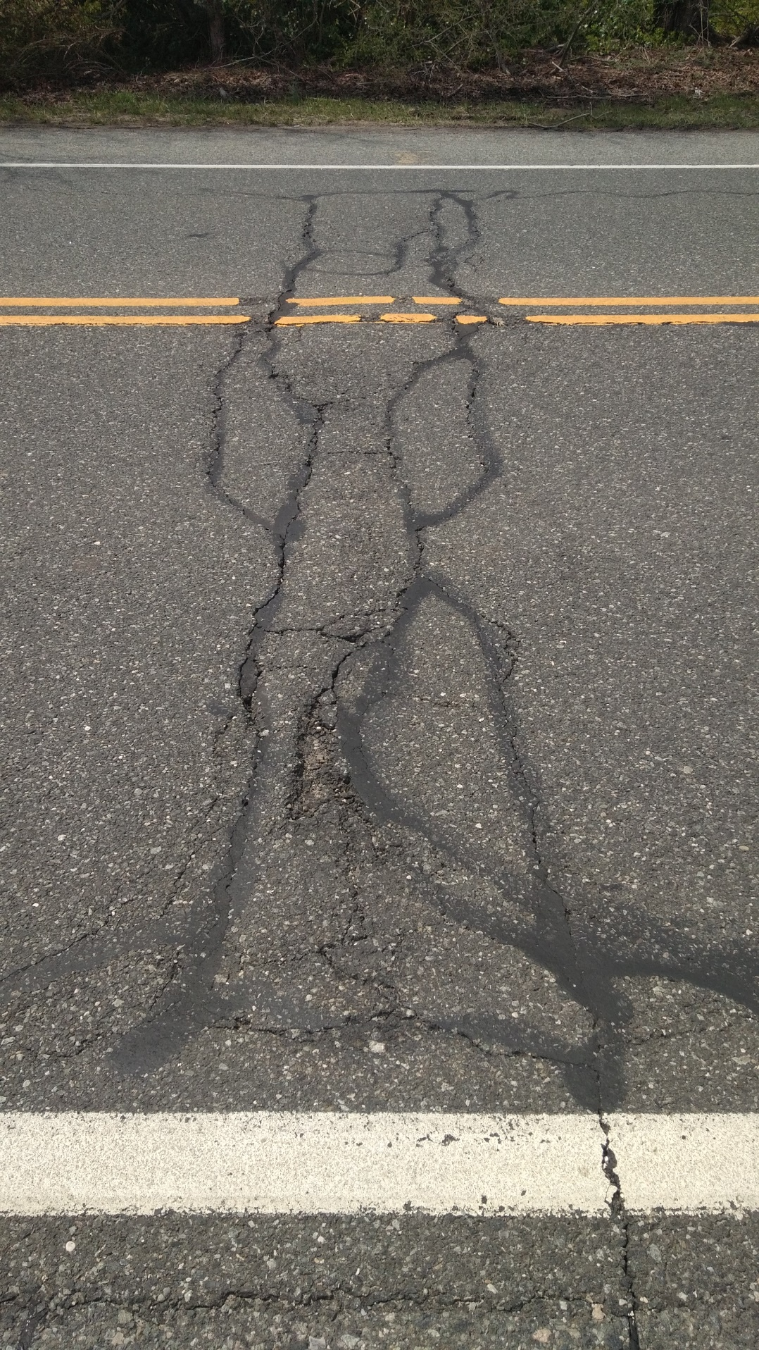
Figure 6 – High Severity Reflective Cracking of Asphalt over a Concrete Pavement Joint (Composite Pavement) Area Requiring Repair
- Rutting and Shoving. No rutting greater than 0.24” and no shoving should be present.
  - Constructing HFST over rutting or areas of shoving will result in thicker and thinner, than design binder thickness, areas of HFST. Thicker than design HFST binder thickness can increase stresses in those areas and cause premature failure of the underlying asphalt. Conversely areas with thinner than design HFST binder thickness can result in loss of performance life via premature raveling of aggregate.
  - Rutting of 0.25” to 1” depth may be micro-milled or diamond ground to smooth the surface and ensure consistent HFST binder thickness.
  - Rutting greater than 1” depth (Figure 7) will, as a minimum, require milling and resurfacing to remove and replace the full width and depth of the affected layer(s) with approved asphalt pavement materials. A pavement evaluation should be performed to determine the cause of rutting. An experienced pavement engineer should review the pavement evaluation. The pavement engineer will then issue a pavement design recommendation that may require milling and resurfacing, pavement structural rehabilitation or pavement reconstruction.
  - If rutting, as determined through the pavement evaluation, is confined only to the surface layer(s), then milling and resurfacing is required to remove and replace the affected layer(s). Pavement layers usually vary in thickness, sometimes as much as 1”. Usually milling an additional 1” depth and replacing the affected layer(s) and some of the material below the affected layer(s) will ensure the entire affected layer(s) is removed and replaced with new asphalt.
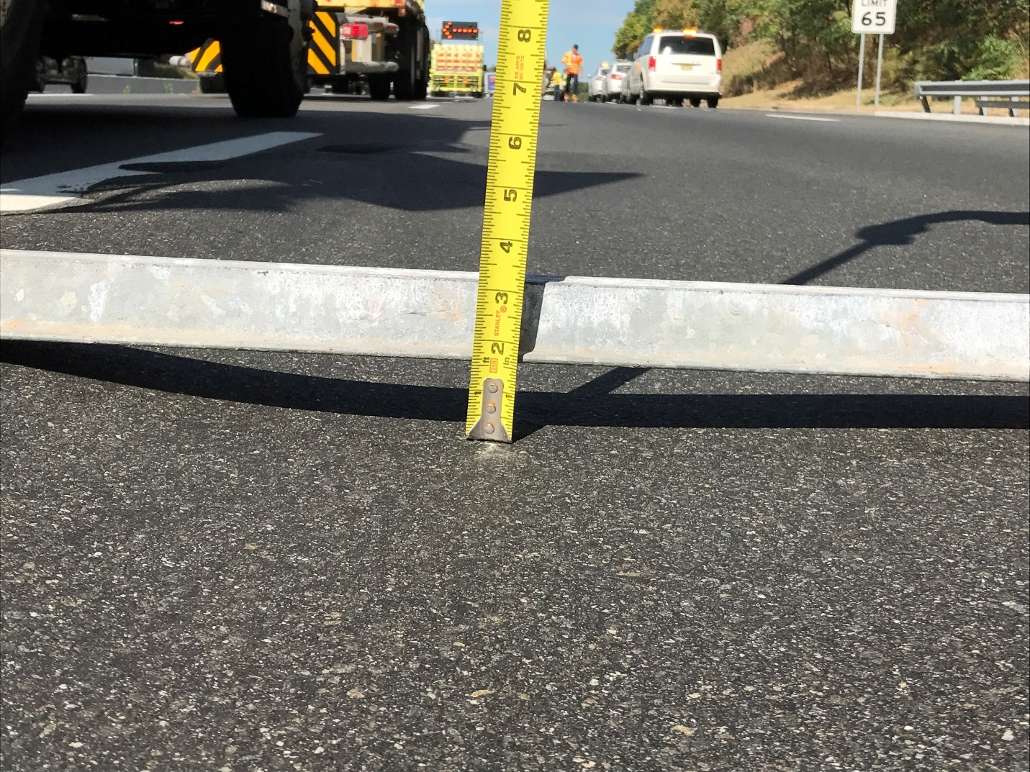
Figure 7a. – Asphalt Rutting in the Wheel Path that Requires Repair
- Potholes. No potholes in the surface.
  - Repair localized potholes using an appropriate approved HMA surface course and good construction practices that meet NJDOT standards.
  - When pothole frequency and density becomes too high (Figure 8), this indicates a performance or structural issue with the pavement. Mill and resurface to remove and replace the full depth of the affected layer(s) in these areas with the required pavement structure and approved asphalt pavement materials.
- Patching. No unsound patching in the surface.
  - Unsound patches should be removed and repaired properly using an appropriate approved HMA surface course and good construction practices that meet NJDOT standards.
  - Patches will often times create an uneven surface that will result in thicker and thinner applications of HFST binder. For areas with few patches, diamond grinding or micro-milling may be used to smooth uneven patched surfaces and prepare them for HFST application.
  - When patch frequency and density becomes too high (Figure 8), this indicates a performance or structural issue with the pavement. Mill and resurface to remove and replace the full depth of the affected layer(s) in these areas with the required pavement structure and approved asphalt pavement materials.
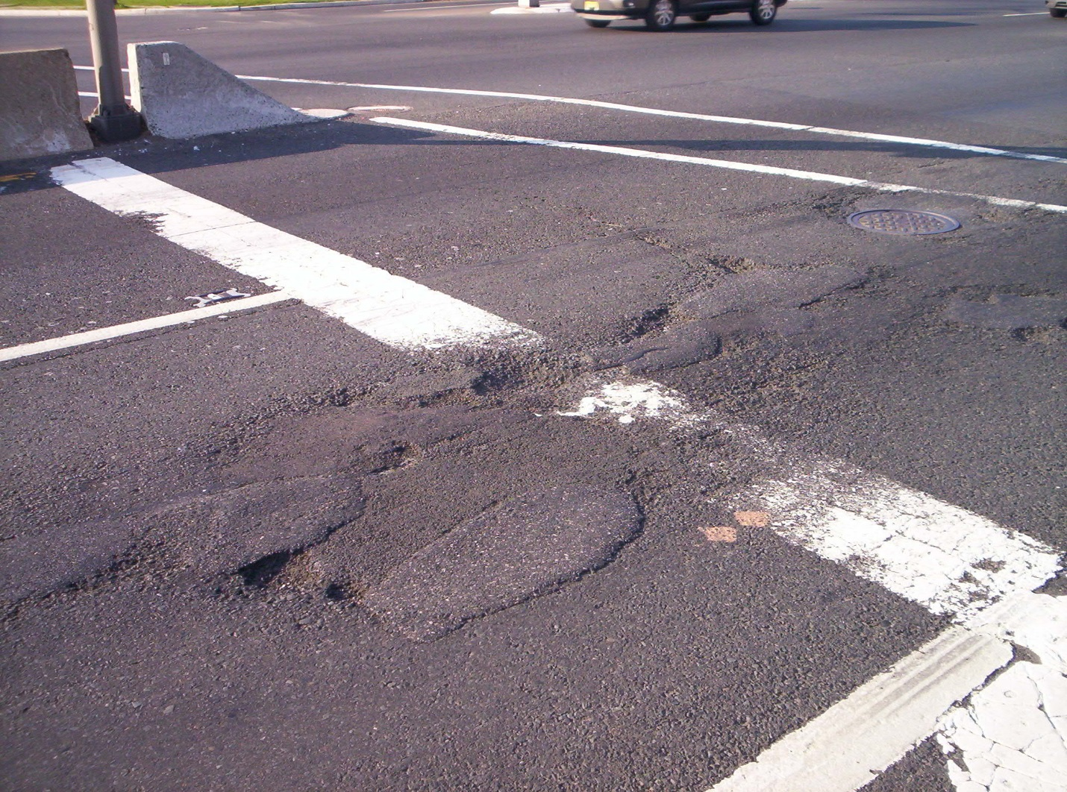
Figure 8 – Asphalt Potholes, Unsound Patching and Raveling Requiring HMA Pavement Repair or Milling and Resurfacing
- Raveling. No raveling, stripping or high air voids (per visual assessment and quality acceptance coring data from previous contract or verified via pavement evaluation cores).
  - Raveling, stripping and high air voids are an indication of inadequate asphalt tensile strength. HFST placed on asphalt pavements with raveling, stripping or high air voids will result in premature failure.
  - As stated previously, HFST is not a preservation treatment and should not be used as an attempt to “seal” or preserve a pavement with raveling, stripping or high air voids. Mill and resurface to remove and replace the full depth of the affected layer(s) in these areas with the required pavement structure and approved asphalt pavement materials.
- Bleeding. No bleeding or flushing of asphalt pavement surface.
  - Bleeding and flushing will reduce the surface texture of the asphalt pavement resulting in poor HFST bonding and premature failure.
  - If the pavement surface shows signs of bleeding or flushing, but based on a pavement evaluation the asphalt is determined to be stable, then micro-milling or diamond grinding may be used to restore the surface texture in preparation for HFST. If the pavement is determined as unstable, then mill and resurface to remove the full depth of the affected layer(s) in these areas.
Asphalt surfaced pavements in good condition and not experiencing any conditions described above should be micro-milled or diamond ground prior to HFST for the following conditions:
- Smoothness. Ride quality measured using International Roughness Index (IRI) is greater than 120 inches per mile.
  - Constructing HFST over pavement with IRI greater than 120 inches per mile may result in areas of thicker than design binder thickness, which can increase stresses in those areas and cause premature failure. Conversely areas with thinner than design binder thickness can result in loss of performance life via premature raveling of aggregate.

Concrete Surfaced Pavements
- Cracking. No structural cracking should be present (Figure 9). Few low severity non-structural cracks may be acceptable such as tight transverse cracks and joints outside the wheel paths of vehicles. Non-structural cracks that have spalling are not acceptable for HFST. The total percentage of low severity non-structural surface cracking should be less than 1 percent.
  - Transverse cracking, longitudinal cracking, patching, spalling, and corner cracking will reflect through HFST and cause premature failure immediately over distress, then adjacent to distress, and eventually beyond distress locations.
  - Clean and fill transverse cracks greater than ¼” and less than 1” width using approved crack sealant.
  - Transverse cracks greater than 1” width and corner cracks require repair and may disqualify the location for HFST. Repair any corner cracks and spalling at transverse cracks with appropriate partial or full depth repair techniques as per American Concrete Pavement Association (ACPA) guidance and NJDOT standards.
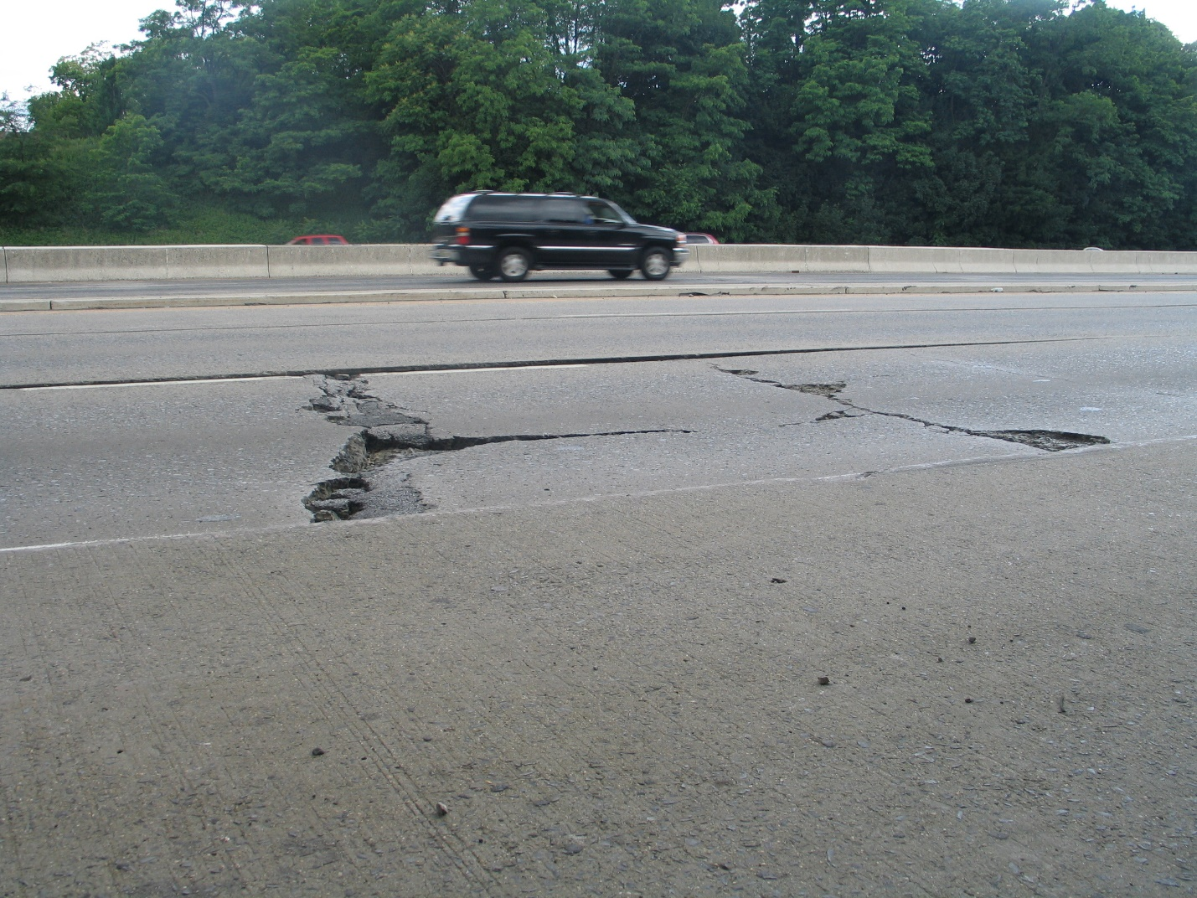
Figure 9 – High Severity Concrete Distress (High Severity Cracking, Spalling, Potholes and Faulting) Requiring Full Depth Slab Repair
- Faulting. No faulting (Figure 9).
  - Concrete faulting is a serious safety concern that needs to be repaired prior to applying HFST.
  - Faulting of 0.25” to 1” depth may be micro-milled or diamond ground to smooth and level the surface. A smooth and level surface will ensure a more consistent HFST binder thickness.
  - Faulting greater than 1” depth may require slab jacking or full slab replacement to level the surface prior to applying HFST.
- Rutting. No rutting.
  - Constructing HFST over rutting will result in thicker and thinner, than design binder thickness, areas of HFST. When the HFST binder thickness is thicker than the intended design thickness, it can increase stresses in those areas and cause premature failure of the HFST. Conversely areas with thinner than design HFST binder thickness can result in loss of performance life via premature raveling of aggregate.
  - Rutting of 0.25” to 1” depth may be micro-milled or diamond ground smooth to cold plane the surface level and ensure consistent HFST binder thickness.
  - Rutting greater than 1” depth will require removal and replacement of the affected panel(s).
- Potholes. No potholes (Figure 9) in the surface.
  - Repair any localized potholes or spalling with appropriate partial or full depth repair techniques as per American Concrete Pavement Association (ACPA) guidance and NJDOT standards.
  - When pothole and spalling frequency and density becomes too high, this indicates a performance or structural issue with the concrete pavement. This condition will require removal and replacement of the affected panel(s).
- Patching. No patching in the surface.
  - Unsound localized patches should be removed and repaired properly using an appropriate partial or full depth repair techniques as per American Concrete Pavement Association (ACPA) guidance and NJDOT standards.
  - Patches will often times create an uneven surface that will result in thicker and thinner applications of HFST binder. For areas with few patches, diamond grinding or micro-milling may be used to smooth uneven patched surfaces and prepare them for HFST application.
  - When patch frequency and density becomes too high, this indicates a performance or structural issue with the concrete pavement. This condition will require removal and replacement of the affected panel(s).
- Scaling. No scaling or other durability issues (per visual assessment and quality acceptance coring data from previous contract or verified via pavement evaluation cores).
  - Raveling and scaling are an indication of durability issues. HFST placed on concrete pavements with durability issues will result in premature failure. Remove and replace any panel(s) affected with durability issues.
Concrete surfaced pavements in good condition and not experiencing any conditions described above should be diamond ground prior to HFST for the following conditions:
- Smoothness. Ride quality measured using International Roughness Index (IRI) is greater than 120 inches per mile.
  - Constructing HFST over pavement with IRI greater than 120 inches per mile will result in areas of thicker than design binder thickness that can increase stresses in those areas and cause premature failure. Conversely areas with thinner than design binder thickness can result in loss of performance life via premature raveling of aggregate.
The distresses listed above for both asphalt surfaced and concrete surfaced pavements are the most common types of distress experienced on NJDOT roadways. There are many other types of pavement surface distress. In no case should HFST be placed over a distressed pavement. A pavement evaluation and suitable pavement repair recommendation, as needed, by an experienced pavement engineer should be performed prior to HFST placement. The cost of HFST is high and although the intention is good to provide a safer, more skid resistant roadway, we as good stewards of the public dollars should be prudent and responsible on picking the right treatment on the right roadway at the right time.

Pavement Evaluation and Materials Testing
Properly repair, resurface, or rehabilitate all pavements as needed prior to applying HFST. Designers should exercise sound pavement engineering judgement and perform the necessary pavement evaluation to determine the condition, structural adequacy and material durability of the pavement. Performing the required pavement evaluation, treatments and repairs prior to installing HFST is critical to ensure the long-term performance and cost effectiveness.
In addition to the visual assessment, review of PMS data, review of as-built and QA/QC data, the pavement engineer may require a pavement evaluation and laboratory testing of pavement samples. If sufficient PMS data, as-built structural information and QC/QA data about the pavement does not exist, then a pavement evaluation and laboratory testing is recommended. Structural adequacy should be evaluated by reviewing as-built pavement data, subgrade soils data, traffic loading data, and using NJDOT standard Pavement Evaluation methods and analysis that typically consist of pavement coring, ground penetrating radar (GPR), and falling weight deflectometer (FWD) testing. The collected data from the pavement evaluation should be analyzed using NJDOT standard items and specifications, AASHTO Guide for Design of Pavement Structures, 4th Edition with 1998 Supplement and AASHTO Mechanistic-Empirical Pavement Design Guide: A Manual of Practice, 2nd Edition to determine structural adequacy of the existing pavement. In addition to NJDOT standard pavement evaluation methods, the tensile strength (ASTM C 1583) of the existing pavement surface course should be evaluated. Composition, binder testing, and tensile strength testing may be required to better characterize the condition of the existing pavement.
Most hot mixed asphalt (HMA) used on NJDOT projects is inspected by Bureau of Materials staff which includes quality assurance (QA) sampling and acceptance testing for conformance with NJDOT specifications. Therefore, most NJDOT projects may not require additional sampling and testing to better characterize the pavement condition. Pavements with no materials inspection, QA sampling and testing require additional evaluation via field testing, sampling and lab testing to determine if the asphalt pavement material has consistent and adequate structural adequacy and tensile strength properties to install HFST. Review by an experienced pavement engineer is required to determine from the pavement evaluation and lab test results if the pavement has consistent and adequate structural integrity, tensile strength and desirable properties to support HFST installation. Proper pavement evaluation and laboratory testing will minimize potential failures and help ensure successful HFST performance.

Continuing HFST Pavement Research
HFST technologies and materials are still evolving. FHWA and AASHTO have drafted the provisional AASHTO specification (PP – 79) based on the initial research and have published those results and general guidance. As a result, NJDOT and other agencies drafted preliminary agency specifications for HFST, but will continue to improve as more data becomes available and experience gained. Research to improve the performance and cost effectiveness of HFST is ongoing. NJDOT has installed several HFST test section as well as some demonstration test sections of new products, materials and techniques similar to HFST that provide friction enhancement to the pavement. Some alternate materials may be more suitable as high friction treatments for specific site conditions.

Figure 10 – High Friction Chip Seal (HFCS) Installation


Figure 11 – High Friction Chip Seal (HFCS) using Calcined Bauxite Aggregate

High Friction Chip Seal (HFCS), as shown in Figures 10 and 11, is one such promising alternative to HFST that provides improved skid resistance to a pavement surface. Like HFST, HFCS uses high quality aggregate (calcined bauxite or other locally sourced high quality aggregate) bonded to pavement surface using a high quality bonding agent. Instead of polymeric epoxy resin binder as the bonding agent for the aggregate, HFCS uses a highly modified asphalt binder with polymers and other additives to provide the required performance. This HFCS binder is better suited for asphalt pavements that may have some minor distress and less than desirable tensile strength. The highly modified asphalt binder used for HFCS is less brittle and more giving than epoxy binders are and behaves similarly to the asphalt pavement substrate during thermal cycling. Because HFCS binder has a similar COTE it is less likely to increase stress at the HFCS/asphalt pavement interface. Researchers have identified large differences in COTE between these bonded materials as a cause of high stress during thermal cycling and subsequent accelerated pavement deterioration in some cases as seen in Figures 4 and 5. HFCS is installed using chip seal equipment. When installing HFCS on a new asphalt pavement, the 30-day waiting period is not required prior to placing HFCS. HFCS will not accelerate deterioration of underlying asphalt pavement due to thermal cycling. HFCS is a fraction of the cost of HFST and can be re-applied when needed. HFCS is still in the pilot phase. NJDOT continue to place pilot test sections, monitor, evaluate and revise specifications and guidance as more data becomes available in the future. Based on data collected so far on NJ projects, HFCS is a suitable cost effective alternative to HFST for asphalt pavements. This guidance for HFST use is applicable to HFCS use on asphalt pavements as well.

NJDOT HFST Specification
See attached non-standard special provision Section 423 High Friction Surface Treatment. This is a draft specification, not a standard specification. As NJDOT becomes more familiar and experienced with HFST, this special specification may be updated. We recommend contacting the NJDOT Pavement Design & Technology unit for the most current specification when considering HFST use.

NJDOT HFCS Specification
See attached non-standard special provision Section 424.03.03 High Friction Chip Seal. This is a draft specification, not a standard specification. As NJDOT becomes more familiar and experienced with HFCS, this special specification may be updated. We recommend contacting the NJDOT Pavement Design & Technology unit for the most current specification when considering HFCS use.

Maintenance Bond
HFST and HFCS specifications require that the contractor provide a maintenance bond for 100% of the contract value of the HFST or HFCS for a period of three (3) years after completion and acceptance. At the end of the three-year maintenance bond period, the Contractor will be released from further work and responsibility, provided previously requested HFST repair work has been satisfactorily completed and approved by the Department. The bond is intended to provide assurance that the HFST or HFCS performs as designed for skid resistance for at least the extent of the bond period and does not ravel or delaminate.

Maintenance of HFST and HFCS
If these guidelines and specifications are followed, then only minimal pavement maintenance typical of standard pavement surfaces would be required over the life of the HFST or HFCS treatment. If within the three-year maintenance bond period the HFST or HFCS exhibits distress as defined in the maintenance bond section of the specifications, then maintenance should be performed as specified. If distresses not defined in the maintenance bond section of the specifications, then repair distressed pavement areas according to the repair recommendations provided above, and if required reapply HFST to restore skid resistance.

Reference Documents

- AASHTO. Guide for Design of Pavement Structures, 4th Edition with 1998 Supplement. American Association of State Highway and Transportation Officials, 1993.
- AASHTO. Mechanistic-Empirical Pavement Design Guide: A Manual of Practice, 2nd Edition. American Association of State Highway and Transportation Officials, 2015.
- FHWA. Distress Identification Manual for Long-Term Pavement Performance Program (Fourth Revised Edition). Publication No. FHWA-RD-03-031, Federal Highway Administration, 2003.
- Texas A & M Transportation Institute. Alternative Aggregates and Materials for High Friction Surface Treatments. Final Report Project BDR74-977-05. Bryan Wilson and Anol Mukhopadhyay, May 2016.

